Section 5.1: Conceptual Data Model
Database Entity–Relationships
Instructions
Read each scenario and decide which type of relationship applies in each scenario, e.g. one-to-one, one-to-many, or many-to-many. Decide what the relationship is between the entities and draw the appropriate relationship arrow between the boxes below.

Relationship arrows

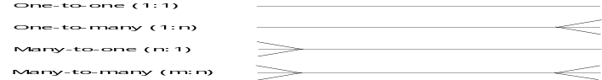

++
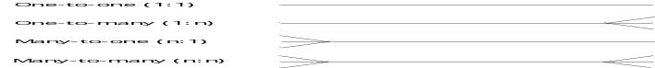

1. Michael’s bookshop
Michael, a bookshop owner, uses a relational database to record details of books and the category in which they can be found on the shelves. A unique International Standard Book Number (ISBN) is assigned to each book. Each book can be allocated one category, e.g. fiction, home and garden, reference, etc. Each category can have many books. What is the relationship between the Category relation and the Book relation?
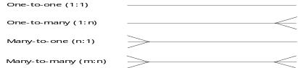
Category
Book

2. Sophie’s prints
Sophie is a printmaker who specialises in limited edition prints of dogs which she creates from her original etchings. She creates 100 identical prints from each etching. She sells her prints through a gallery in her local town. Each etching is assigned a unique name. She records the name of the etching each customer has bought but does not record the numbered print they buy. Her sales are stored in a database with three relations: Etching, Sales and Customers. What is the relationship between the Customer relation and the Etching relation?


Customer
Etching

3. Bradley’s blog
Bradley, an A-level Computing student, has started a blog to share resources on his computing lessons with his fellow students. He posts to his blog after each lesson a summary of the theory covered that day. His fellow students can then add their comments to each post. His blog is stored in an online database with two relations – Blog and Comment. What is the relationship between the Blog relation and the Comment relation?
Blog
Comment

4. Louise’s French lessons
Louise is taking an evening class in French. She has decided to record her French vocabulary in a database so that she can easily search for words as she needs them. Her French teacher has given her 100 pairs of English-French translations to learn. She has stored the French words in a table and the English words in a separate table. What is the relationship between the French relation and the English relation?
French
English

5. Computer room bookings
A secondary school has three computer rooms each with 30 computers that can be booked out for a whole lesson during any school day. Teachers, Rooms and Bookings are recorded in tables. The booking table records the lesson, date, teacher and room to be booked. A room can only be booked out once for each lesson. What is the relationship between the Teacher relation and the Booking relation?

Teacher
Booking

6. Satellite road navigation
A satellite navigation device stores its maps on a database. It stores each road in one table and each junction in another table. The junction table identifies which roads join at each junction. The road table identifies the name of each road and a unique number is assigned to each road. A further table road junction identifies the distance between each junction via each road. What is the relationship between the Road relation and the Junction relation?

Road
Junction

